Indexing
1 No need to add primary key and unique columns to add in indexing because it will automatically added and searching will already fast
2 Index columns that you are accessing frequently
3 Index columns that are used for joins to improve join performance
4 Avoid columns that contains too many NULL values
5 Avoid indexing in small table
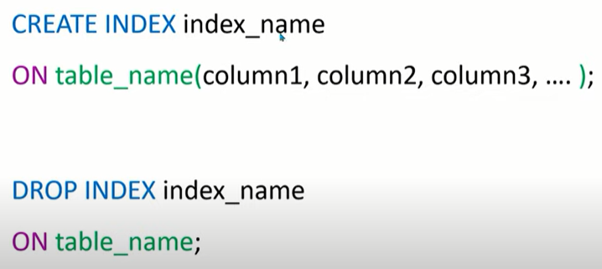
Index will show best result when there are more number of records ie in thousand and lac
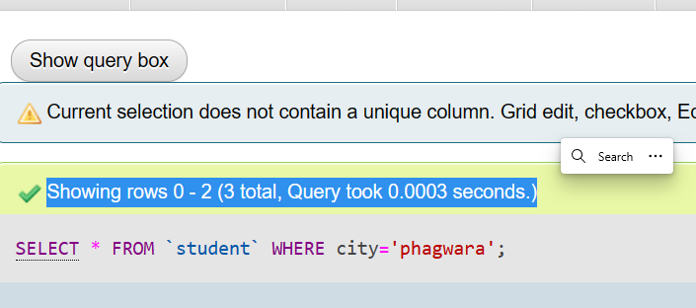
It will take more time if executed without index

Now if you are useng same quey then it will take less time to execute
To display the created index of table
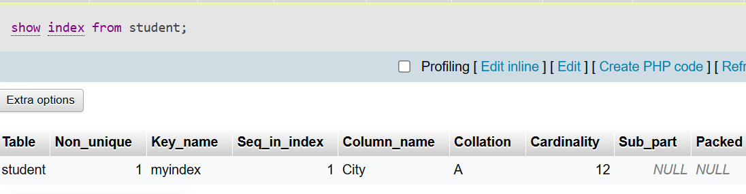
To delete Index
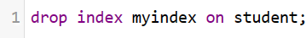

MySQL Table Types/Storage Engines
MySQL table types/storage engines are essential features that can be used effectively for maximizing the database's performance. It handles create, read, and update operations for storing and managing the information in a database. In this tutorial, we are going to understand various storage engines or table types used in MySQL.
mysql> SHOW ENGINES;
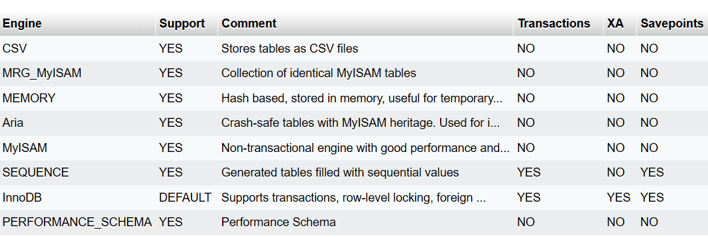
SHOW ENGINES output has these columns:
- Engine
The name of the storage engine.
- Support
The server's level of support for the storage engine, as shown in the following table.
Value | Meaning
YES | The engine is supported and is active
DEFAULT | Like YES, plus this is the default engine
NO | The engine is not supported
DISABLED | The engine is supported but has been disabled

A value of NO means that the server was compiled without support for the engine, so it cannot be enabled at runtime.
A value of DISABLED occurs either because the server was started with an option that disables the engine, or because not all options required to enable it were given. In the latter case, the error log should contain a reason indicating why the option is disabled

You might also see DISABLED for a storage engine if the server was compiled to support it, but was started with a --skip-engine_name option. For the NDB storage engine, DISABLED means the server was compiled with support for NDB Cluster, but was not started with the --ndbcluster option.
All MySQL servers support MyISAM tables. It is not possible to disable MyISAM.
- Comment
A brief description of the storage engine.
- Transactions
Whether the storage engine supports transactions.
- XA
Whether the storage engine supports XA transactions.
The XA interface to a MySQL server consists of SQL statements that begin with the XA keyword. MySQL client programs must be able to send SQL statements and to understand the semantics of the XA statement interface.
- Savepoints
Whether the storage engine supports savepoints.
You are not restricted to using the same storage engine for an entire server or schema. You can specify the storage engine for any table. For example, an application might use mostly InnoDB tables, with one CSV table for exporting data to a spreadsheet and a few MEMORY tables for temporary workspaces.
Choosing a Storage Engine
The various storage engines provided with MySQL are designed with different use cases in mind. The following table provides an overview of some storage engines provided with MySQL, with clarifying notes following the table.

Table Storage Engines Feature Summary
Feature | MyISAM | Memory | InnoDB | Archive | NDB
B-tree indexes | Yes | Yes | Yes | No | No
Backup/point-in-time recovery (note 1) | Yes | Yes | Yes | Yes | Yes
Cluster database support | No | No | No | No | Yes
Clustered indexes | No | No | Yes | No | No
Compressed data | Yes (note 2) | No | Yes | Yes | No
Data caches | No | N/A | Yes | No | Yes
Encrypted data | Yes (note 3) | Yes (note 3) | Yes (note 4) | Yes (note 3) | Yes (note 3)
Foreign key support | No | No | Yes | No | Yes (note 5)
Full-text search indexes | Yes | No | Yes (note 6) | No | No
Geospatial data type support | Yes | No | Yes | Yes | Yes
Geospatial indexing support | Yes | No | Yes (note 7) | No | No
Hash indexes | No | Yes | No (note 8) | No | Yes
Index caches | Yes | N/A | Yes | No | Yes
Locking granularity | Table | Table | Row | Row | Row
MVCC | No | No | Yes | No | No
Replication support (note 1) | Yes | Limited (note 9) | Yes | Yes | Yes
Storage limits | 256TB | RAM | 64TB | None | 384EB
T-tree indexes | No | No | No | No | Yes
Transactions | No | No | Yes | No | Yes
Update statistics for data dictionary | Yes | Yes | Yes | Yes | Yes

Setting the Storage Engine
When you create a new table, you can specify which storage engine to use by adding an ENGINE table option to the CREATE TABLE statement:
-- ENGINE=INNODB not needed unless you have set a different
-- default storage engine.
CREATE TABLE t1 (i INT) ENGINE = INNODB;
-- Simple table definitions can be switched from one to another.
CREATE TABLE t2 (i INT) ENGINE = CSV;
CREATE TABLE t3 (i INT) ENGINE = MEMORY;
When you omit the ENGINE option, the default storage engine is used. The default engine is InnoDB in MySQL 5.7. You can specify the default engine by using the --default-storage-engine server startup option, or by setting the default-storage-engine option in the my.cnf configuration file.
You can set the default storage engine for the current session by setting the default_storage_engine variable:
SET default_storage_engine=NDBCLUSTER;
The storage engine for TEMPORARY tables created with CREATE TEMPORARY TABLE can be set separately from the engine for permanent tables by setting the default_tmp_storage_engine, either at startup or at runtime.
To convert a table from one storage engine to another, use an ALTER TABLE statement that indicates the new engine:
ALTER TABLE t ENGINE = InnoDB;

Introduction to InnoDB

Key Advantages of InnoDB
- Its DML operations follow the ACID model, with transactions featuring commit, rollback, and crash-recovery capabilities to protect user data..
- Row-level locking and Oracle-style consistent reads increase multi-user concurrency and performance.
- InnoDB tables arrange your data on disk to optimize queries based on primary keys. Each InnoDB table has a primary key index called the clustered index that organizes the data to minimize I/O for primary key lookups..
- To maintain data integrity, InnoDB supports FOREIGN KEY constraints. With foreign keys, inserts, updates, and deletes are checked to ensure they do not result in inconsistencies across related tables.

InnoDB Storage Engine Features
Feature | Support
B-tree indexes | Yes
Backup/point-in-time recovery (Implemented in the server, rather than in the storage engine.) | Yes
Cluster database support | No
Clustered indexes | Yes
Compressed data | Yes
Data caches | Yes
Encrypted data | Yes (Implemented in the server via encryption functions; In MySQL 5.7 and later, data-at-rest encryption is supported.)
Foreign key support | Yes
Full-text search indexes | Yes (Support for FULLTEXT indexes is available in MySQL 5.6 and later.)
Geospatial data type support | Yes
Geospatial indexing support | Yes (Support for geospatial indexing is available in MySQL 5.7 and later.)
Hash indexes | No (InnoDB utilizes hash indexes internally for its Adaptive Hash Index feature.)
Index caches | Yes
Locking granularity | Row
MVCC | Yes
Replication support (Implemented in the server, rather than in the storage engine.) | Yes
Storage limits | 64TB
T-tree indexes | No
Transactions | Yes
Update statistics for data dictionary | Yes

SQL JOIN
As the name shows, JOIN means to combine something. In case of SQL, JOIN means "to combine two or more tables".
The SQL JOIN clause takes records from two or more tables in a database and combines it together.
ANSI standard SQL defines five types of JOIN :
- inner join,
- left outer join,
- right outer join,
- full outer join, and
- cross join.

Why SQL JOIN is used?
If you want to access more than one table through a select statement.
If you want to combine two or more table then SQL JOIN statement is used .it combines rows of that tables in one table and one can retrieve the information by a SELECT statement.
The joining of two or more tables is based on common field between them.
SQL INNER JOIN also known as simple join is the most common type of join.

How to use SQL join or SQL Inner Join?
Let an example to deploy SQL JOIN process:
1.Staff table
ID | Staff_NAME | Staff_AGE | STAFF_ADDRESS | Monthley_Package
1 | ARYAN | 22 | MUMBAI | 18000
2 | SUSHIL | 32 | DELHI | 20000
3 | MONTY | 25 | MOHALI | 22000
4 | AMIT | 20 | ALLAHABAD | 12000
2.Payment table
Payment_ID | DATE | Staff_ID | AMOUNT
101 | 30/12/2009 | 1 | 3000.00
102 | 22/02/2010 | 3 | 2500.00
103 | 23/02/2010 | 4 | 3500.00
So if you follow this JOIN statement to join these two tables ?
- SELECT Staff_ID, Staff_NAME, Staff_AGE, AMOUNT
- FROM STAFF s, PAYMENT p
- WHERE s.ID =p.STAFF_ID;
This will produce the result like this:
STAFF_ID | NAME | Staff_AGE | AMOUNT
3 | MONTY | 25 | 2500
1 | ARYAN | 22 | 3000
4 | AMIT | 25 | 3500
1 | ARYAN | 22 | 3000

INNER JOIN
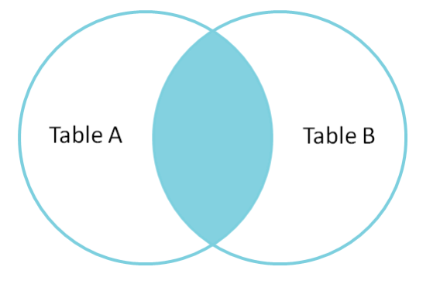

. LEFT JOIN
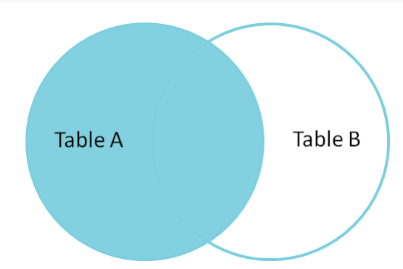

RIGHT JOIN
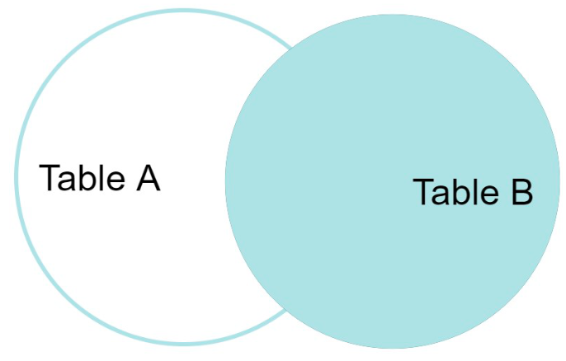

FULL JOIN
